Living a zero-waste lifestyle
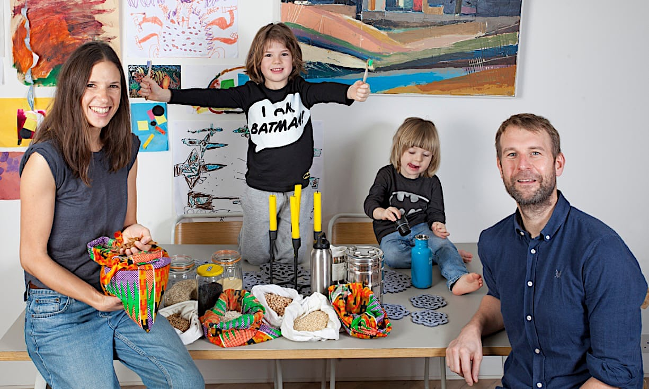
Before you read

1. Look at the picture and read the title. Say what the text is about.

2. Define “zero waste” in your own words, then imagine how this family lives.

Life without plastic: pioneer families show how it’s done
Carrier bags are easy to replace and milk can come in glass bottles. But what about deodorant, toothbrushes and clingfilm?

Nosheen Iqbal
Sat 29 Dec 2018
1
Bettina Maidment hasn’t emptied the kitchen bin since the beginning of November. The time before that was in August. “You can reduce your rubbish a lot,” she insists, pointing to her recycling and food compost bins. “I have two kids and they’re pretty anti-plastic – I am their mother after all – but it is do-able.”
Maidment, 38, is the founder of Plastic Free Hackney, a campaign to rid the east London borough of single-use plastic and has been serious about committing her family to plastic-free, zero-waste living for two years now. First to go was milk cartons. “That was an easy switch, we got a milkman.”
5
Then came bamboo toothbrushes, swapping out supermarket shopping for the local greengrocer, and making deodorant, cleanser, moisturiser and handsoap at home. She opens her fridge to reveal shelves of glass jars and reusable containers; her larder is stocked with lentils, pasta, porridge and the like, bought in bulk and stored in glass or canvas bags.
10
“At the moment, there are all these headlines about sales in shops being down, but maybe everyone has enough stuff.”
Her aim, she says, is to instill the principle in her sons, who are three and six, “that they can be happy with as little as possible”.
15
She is not alone. As public anger grows over the environmental impact of single-use plastic, trying to live plastic-free and more sustainably has become a mainstream concept. “There was a huge uptick in the conversation after Blue Planet¹ about how to reduce plastic use and it remains, by quite a margin, the single biggest topic area people call us for,” says Julian Kirby, lead campaigner on plastics at Friends of the Earth. “In my experience, the amount of public concern for this environmental issue is unprecedented,” he says. “It’s been phenomenal.”
20
Maidment admits that her gradual awareness of the amount of plastic and litter in the street has become an obsession. Now, everything that can be is reused, recycled, bought on eBay or sourced from a charity shop². The family have had their second “buy nothing new” Christmas. Maidment’s husband works as an engineer in sustainable design but she didn’t tell him about her project at the beginning.
“My interest was piqued online and I saw how other people were doing it and slowly started reducing my waste.” She opened an Instagram account to document the process of going plastic-free. “It was very much a secret at first – I thought people would think I was mad – but I couldn’t reconcile the idea that so much of what we buy is designed to be thrown away. It’s insanity.”
25
1
https://www.theguardian.com/environment/2018/dec/29/how-to-live-without-plastic
1. Blue Planet: une série de documentaires réalisée par la BBC. 2 : Charity shop : friperie

Now read

Work on words

1. Use the context

In the text, find the synonyms for these words.

Trash = …………………. To engage = ………………. Pots = ………………. Very popular = …………………….
Never known before = ………………………..…. quantity= ………………. madness= ……………….

2 Compound nouns

a. Observe these words and explain how they are made.
Compost bins : …………………………………………………….
milk cartoons : …………………………………………………….
Toothbrushes: …………………………………………………….
Greengrocer: …………………………………………………….
Handsoap: …………………………………………………….
Glass jar: …………………………………………………….
Charity shop: …………………………………………………….

b. Now translate these words into English.
Une barre de savon: …………………. Une campagne de prévention: ……………..…….
Une benne de recyclage: ……………………. Du gel douche : …………………………….
Un sac de pommes de terre : ……………………. Une décision prise en famille : …………………….

Comprehension

I) Read lines 1 to 6

1. Pick out information about the characters.
The name of the main character: …………………………………………
Her age: …………………………………………
Who the members of her family are: ……………………………………………………………………………………

2. Pick out in the text:
a. a synonym for waste: …………………………………………
b. where we usually put waste in: ………………………………………
c. other things we can do with waste: ………………………………………… and …………………………………………

3. Find quotes explaining this family’s position about waste.
…………………………………………………………………………………………………………………………………………
…………………………………………………………………………………………………………………………………………

4. Pick out information about the campaign led by the family.
The name of the campaign: …………………………………………
Location: …………………………………………
Objective: …………………………………………
When it started: …………………………………………

5. Fill in the blanks to complete the script using the words you’ve found above:
…………………… …………………… is a mother of ……………………… This family doesn’t put their ………………… into the ……………………… They ………………… or ……………… it instead. It is possible because this family is …………………… and they want to ……………………… …………………… ………………… a lot. They have started a campaign called …………………………, which started ………………, in order to …………………………………………

2. Focus on lines 7 to 15

6. Find the things or activities they have stopped doing. Then say they have replaced them with. (Find the information in the text or imagine it.)

They have stopped… | They have replaced it with…

7. Find names of materials they have instead of plastic. …………………………… and ……………………………

8. a. Quote the sentence which explains their point of view about consumption.
…………………………………………………………………………………………………………………………………………
b. Say who is concerned in her family: ………………………………………
c. Quote what she wants for her family: …………………………………………

9. Rephrase in your own words what they have done and what their objective is.
…………………………………………………………………………………………………………………………………………
…………………………………………………………………………………………………………………………………………
3. Focus on lines 15 to 19

10. a. Say who is speaking in this paragraph.
Name: …………………………………………
Organization: …………………………………………
Role: ………………………………………

b. Use the name of the organization and the role the person has to explain what they are and what they want.
……………………………………………………………………………………………………………………………………………

11. a. Circle the general public’s reaction to this issue BEFORE AND TODAY.

b. Quote the word which helped you to answer. …………………………………………
c. Quote what the general public wants to do: …………………………………… and ………………………………………
d. Explain what changed the public’s opinion about the topic. ……………………………………………………………………………………………………………………………………………
……………………………………………………………………………………………………………………………………………

4. Focus on lines 20 to 23

12. Quote four ways the family have found to reach their objective.
……………………………………………………………………………………………………………………………………………
……………………………………………………………………………………………………………………………………………

13. Explain what they did at Christmas. Explain what it means.
……………………………………………………………………………………………………………………………………………
……………………………………………………………………………………………………………………………………………

5. Focus on lines 24 to 27

14. Find the following elements.
- How she found information: …………………………………………
- What she did to start her campaign: …………………………………………
- How public it was: …………………………………………
- What she thought in the beginning: …………………………………………

15. Fill in the blanks with the elements you have found.
Bettina first found information …………………………… Then, she opened ………………………… to explain her action. In the beginning, it was …………………………… because she thought ………………………………

16. Explain the last sentence. Say what she thinks about our current consumption mode and why.
In her opinion, it is …………………………………… because ……………………………………………………………….

17. Recap what you have understood.

React

Discuss this statement : « There are headlines about sales in shops being down. Maybe everyone has enough stuff.” (l. 11-12)

THE STEPS YOU CAN TAKE…

Use a reusable water bottle
Plastic bottles remain the second most common single-use plastic polluting the planet – after cigarette butts.

Carry a reusable cup
Most coffee chains offer a discount to customers bringing in their own cups because 99.75% of takeaway coffee cups are not recycled in the UK.

Switch to solid soaps
Liquid shower gels and handwash can be one of the biggest sources of household plastic waste.

Say no to disposable cutlery
The EU plans to ban single-use cutlery, plates, straws, cotton buds, drink stirrers and balloon sticks by 2021.

Brush with bamboo
From hair-brushes to toothbrushes, switch to biodegradable options.

GRAMMAR
Les conseils et les consignes
Observe

a. Waste production has to be reduced a lot.
b. Residents need to realize that we produce too much waste.
c. Milk cartons should be replaced by glass bottles.
d. Stop buying products in plastic packaging or recycle them. Don’t leave them in nature.

Déduis.
Lis les phrases a à d. Laquelle exprime :
- Le conseil ?
- La nécessité ?
- Une consigne ?
- Un ordre ?

Dites quelles tournures permettent d’exprimer cela.

Observe la phrase d. A qui parle-t-on ? Comment construit-on cette forme ?

Observe les phrases a et c. Sur qui souhaite-t-on agir ici ? Comment le sait-on ?

Entraine-toi

Translate the following sentences into English.

a. Tout le monde devrait recycler ses déchets autant que possible.

b. Il est nécessaire que les gens aient conscience de la situation.

c. Les associations de protection de l’environnement peuvent donner des conseils aux consommateurs.

d. « Ne jette pas ce jean, il est encore en bon état ! »

Living a zero-waste lifestyle
Before you read

1. Look at the picture and read the title. Say what the text is about.

2. Define “zero waste” in your own words,then imagine how this family lives.

Life without plastic: pioneer families show how it’s done
Carrier bags are easy to replace and milk can come in glass bottles. But what about deodorant, toothbrushes and clingfilm?

Nosheen Iqbal
Sat 29 Dec 2018
1
Bettina Maidment hasn’t emptied the kitchen bin since the beginning of November. The time before that was in August. “You can reduce your rubbish a lot,” she insists, pointing to her recycling and food compost bins. “I have two kids and they’re pretty anti-plastic – I am their mother after all – but it is do-able.”
5
Maidment, 38, is the founder of Plastic Free Hackney, a campaign to rid the east London borough of single-use plastic and has been serious about committing her family to plastic-free, zero-waste living for two years now. First to go was milk cartons. “That was an easy switch, we got a milkman.”
Then came bamboo toothbrushes, swapping out supermarket shopping for the local greengrocer, and making deodorant, cleanser, moisturiser and handsoap at home. She opens her fridge to reveal shelves of glass jars and reusable containers; her larder is stocked with lentils, pasta, porridge and the like, bought in bulk and stored in glass or canvas bags.
10
“At the moment, there are all these headlines about sales in shops being down, but maybe everyone has enough stuff.”
Her aim, she says, is to instill the principle in her sons, who are three and six, “that they can be happy with as little as possible”.
15
She is not alone. As public anger grows over the environmental impact of single-use plastic, trying to live plastic-free and more sustainably has become a mainstream concept. “There was a huge uptick in the conversation after Blue Planet¹ about how to reduce plastic use and it remains, by quite a margin, the single biggest topic area people call us for,” says Julian Kirby, lead campaigner on plastics at Friends of the Earth. “In my experience, the amount of public concern for this environmental issue is unprecedented,” he says. “It’s been phenomenal.”
20
Maidment admits that her gradual awareness of the amount of plastic and litter in the street has become an obsession. Now, everything that can be is reused, recycled, bought on eBay or sourced from a charity shop². The family have had their second “buy nothing new” Christmas. Maidment’s husband works as an engineer in sustainable design but she didn’t tell him about her project at the beginning.
25
“My interest was piqued online and I saw how other people were doing it and slowly started reducing my waste.” She opened an Instagram account to document the process of going plastic-free. “It was very much a secret at first – I thought people would think I was mad – but I couldn’t reconcile the idea that so much of what we buy is designed to be thrown away. It’s insanity.”
30
https://www.theguardian.com/environment/2018/dec/29/how-to-live-without-plastic
1. Blue Planet: une série de documentaires réalisée par la BBC. 2 : Charity shop : friperie

Now read

Work on words

1. Use the context

In the text, find the synonyms for these words.

Trash = …………………. To engage = ………………. Pots = ……………….
Very popular = ……………………. Never known before = ………………….….
quantity= ………………. madness= ……………….

2 Compound nouns

a. Observe these words and explain how they are made.
Compost bins : …………………………………………………….
milk cartoons : …………………………………………………….
Toothbrushes: …………………………………………………….
Greengrocer: …………………………………………………….
Handsoap: …………………………………………………….
Glass jar: …………………………………………………….
Charity shop: …………………………………………………….

b. Now translate these words into English.
Une barre de savon: …………………. Une campagne de prévention: ……………..…….
Une benne de recyclage: ……………………. Du gel douche : …………………………….
Un sac de pommes de terre : ……………………. Une décision prise en famille : …………………….

Comprehension

I) Read lines 1 to 7

1. Pick out information about the characters.
The name of the main character: …………………………………………
Her age: …………………………………………
Who the members of her family are: …………………………………………………………………………

2. Pick out in the text:
a. a synonym for waste: …………………………………………
b. where we usually put waste in: ………………………………………
c. other things we can do with waste: ……………………………… and …………………………………

3. Find quotes explaining this family’s position about waste.
……………………………………………………………………………………………………………………
……………………………………………………………………………………………………………………

4. Pick out information about the campaign led by the family.
The name of the campaign: …………………………………………
Location: …………………………………………
Objective: …………………………………………
When it started: …………………………………………

5. Fill in the blanks to complete the script using the words you’ve found above:
…………………… …………………… is a mother of ……………………… This family doesn’t put their ………………… into the ……………………… They ………………… or ……………… it instead. It is possible because this family is …………………… and they want to ……………………… …………………… ………………… a lot. They have started a campaign called …………………………, which started ………………, in order to …………………………………………

2. Focus on lines 8 to 16

6. Find the things or activities they have stopped doing. Then say they have replaced them with. (Find the information in the text or imagine it.)

They have stopped… | They have replaced it with…

7. Find names of materials they have instead of plastic. ………………… and ………………………

8. a. Quote the sentence which explains their point of view about consumption.
……………………………………………………………………………………………………………………
b. Say who is concerned in her family: ………………………………………
c. Quote what she wants for her family: …………………………………………

9. Rephrase in your own words what they have done and what their objective is.
……………………………………………………………………………………………………………………
……………………………………………………………………………………………………………………

3. Focus on lines 16 to 21

10. a. Say who is speaking in this paragraph.
Name: …………………………………………
Organization: …………………………………………
Role: ………………………………………

b. Use the name of the organization and the role the person has to explain what they are and what they want.
……………………………………………………………………………………………………………………

11. a. Circle the general public’s reaction to this issue BEFORE AND TODAY.
b. Quote the word which helped you to answer. …………………………………………
c. Quote what the general public wants to do: ……………………… and ………………………………
d. Explain what changed the public’s opinion about the topic. ……………………………………………………………………………………………………………………
……………………………………………………………………………………………………………………

4. Focus on lines 22 to 26

12. Quote four ways the family have found to reach their objective.
……………………………………………………………………………………………………………………
……………………………………………………………………………………………………………………

13. Explain what they did at Christmas. Explain what it means.
……………………………………………………………………………………………………………………
……………………………………………………………………………………………………………………

5. Focus on lines 27 to 30

14. Find the following elements.
- How she found information: …………………………………………
- What she did to start her campaign: …………………………………………
- How public it was: …………………………………………
- What she thought in the beginning: …………………………………………

15. Fill in the blanks with the elements you have found.
Bettina first found information ………………… Then, she opened …………………… to explain her action. In the beginning, it was ……………………… because she thought ………………………………

16. Explain the last sentence. Say what she thinks about our current consumption mode and why.
In her opinion, it is …………………………… because ………………………………………………….

17. Recap what you have understood.

React

Discuss this statement : « There are headlines about sales in shops being down. Maybe everyone has enough stuff.” (l. 11-12)

THE STEPS YOU CAN TAKE…

Use a reusable water bottle
Plastic bottles remain the second most common single-use plastic polluting the planet – after cigarette butts.

Carry a reusable cup
Most coffee chains offer a discount to customers bringing in their own cups because 99.75% of takeaway coffee cups are not recycled in the UK.

Switch to solid soaps
Liquid shower gels and handwash can be one of the biggest sources of household plastic waste.

Say no to disposable cutlery
The EU plans to ban single-use cutlery, plates, straws, cotton buds, drink stirrers and balloon sticks by 2021.

Brush with bamboo
From hair-brushes to toothbrushes, switch to biodegradable options.

GRAMMAR
Les conseils et les consignes
Observe

a. Waste production has to be reduced a lot.
b. Residents need to realize that we produce too much waste.
c. Milk cartons should be replaced by glass bottles.
d. Stop buying products in plastic packaging or recycle them. Don’t leave them in nature.

Déduis.
Lis les phrases a à d. Laquelle exprime :
- Le conseil ?
- La nécessité ?
- Une consigne ?
- Un ordre ?

Dites quelles tournures permettent d’exprimer cela.

Observe la phrase d. A qui parle-t-on ? Comment construit-on cette forme ?

Observe les phrases a et c. Sur qui souhaite-t-on agir ici ? Comment le sait-on ?

Entraine-toi

Translate the following sentences into English.

a. Tout le monde devrait recycler ses déchets autant que possible.

b. Il est nécessaire que les gens aient conscience de la situation.

c. Les associations de protection de l’environnement peuvent donner des conseils aux consommateurs.

d. « Ne jette pas ce jean, il est encore en bon état ! »

