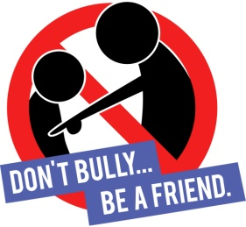

SPEAK UP AGAINST BULLYING!

- Write a definition of BULLYING :
…………………………………………………………………………………………………
…………………………………………………………………………………………………

- Match the words and their synonyms:

- A bully | Nasty, unkind, cruel: ……….
- A victim | A tormentor, a tyrant, a persecutor: ……….
- (to) abuse | A prey, a scapegoat: ……….
- Power | (to) ill-treat, (to) hurt, (to) harm: ……….
- Mean | Authority, control: ……….

- (to) insult | An attack, an assault : ……….
- Sympathy | (to) threaten: ……….
- (to) intimidate | An attacker: ……….
- An aggression | Compassion, pity: ……….
- Aggressive | (to) call names: ……….
- An aggressor | Threatening, belligerent: ……….

- Violence | Self-murder: ……….
- Suicide | (to) nag, (to) disparage: ……….
- (to) criticise | Force, brutality: ……….
- Gossip | Rumour, hearsay : ……….
- Hostile | Antagonistic, unfriendly: ……….

- Match the words and their definition:
- Repetitively | (to) follow (a person) continually, usually to gain attention: ……….
- (to) harass | One who is the object of abuse. : ……….
- Happy slapping | Repeatedly: ……….
- (to) stalk | The act of disturbing repeatedly: ……….
- Harassment | The fact of attacking a victim for the purpose of recording the assault: ……….
- A target | (to) annoy continuously: ……….

- A bystander | The use of force or intimidation to obtain cooperation: ……….
- Coercion | (to) come between people who are disagreeing: ……….
- (to) intervene | (to) make known the actions or conduct of somebody: ……….
- Intimidation | A person present but not involved: ……….
- (to) report | The act of intimidating a weaker person to make them do something : ……….

- Guilty | (to) irritate or provoke a person with jokes and/or annoyances: ……….
- Innocent | Responsible for an offence or a crime: ……….
- (to) tease | A person who lacks courage: ……….
- A coward | Not guilty of a particular crime: ……….

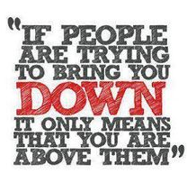

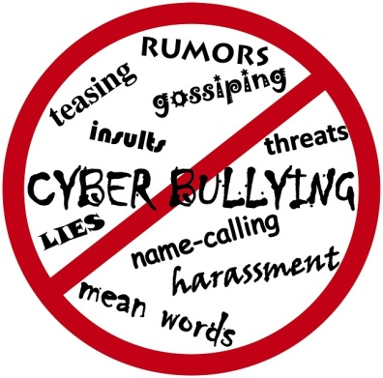
Bullying

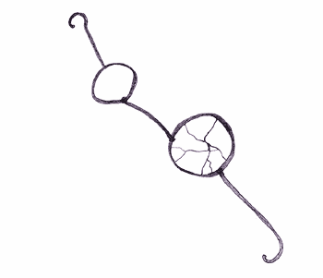

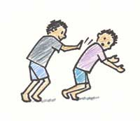

Match an expression with its picture:
- People calling you names= insult
- Hitting
- Taking things away from you.
- Spreading rumors.
- Threats and intimidation.
- Sending you offensive phone texts.
- Taking you friends away from you.
- Stealing your money.
- Damaging your belongings.
- Pinching
- Pushing
- Shoving

